Aimee Valladares

U0000007023

Computer Science, Software Engineering

**Assignment 1**

The Augmented Reality experience I created was to have a detailed spaceship fly over a 2D image of a nebula meant to signify that the 3D object is traveling through space. When first developing the application, I imported a detailed and textured 3D model from cgtrader. The scene consists of the Directional Light, AR Camera, and an Image Target. The Image Target contains several elements that enable the AR experience to occur. First, the Image Target utilizes a 2D image of a distinct Europa poster from a newly created database (Figure 2). This allows camera devices to recognize the image and set up the AR environment. Then there is the 3D object, which is a spaceship (Figure 3). The 3D object contains an animation done in unity. Then there is a virtual button that allows the user to trigger the 3D object’s animation (Figure 4). Finally, there is a virtual texture of a nebula that projects over the Europa poster (Figure 5). Finally, the Image Target contains the script that enables the button functionality to occur. Specifically, it is responsible for the button actions that the user can do when the AR experience is occurring, namely pressing the button.

The expected outcome of using the Augmented Reality experience is to have a web cam that is meant to emulate a mobile device detect the Europa Poster. Once the device recognizes the poster as an image target, the virtual texture, virtual button, and the 3D spaceship model will appear on the image target. Once the virtual elements are displayed, the user can then reach and try to *press* and *hold* the “Launch Button”. Once the button is pressed, the spaceship will move and quickly complete a loop and then return to its original position. The action can be repeated.

**Figure 1. Overall Scene Through Development**

**Figure 2. 2D Object – Europa Poster**

**Figure 3. 3D Object – Cool Spaceship**

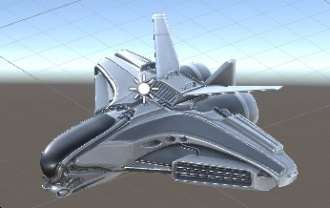

**Figure 4. Virtual Button**

**Figure 5. Virtual Texture**

